
Touchstones Project
Netcards

Activism Netcards with Text

Arc HRJ
Birmingham Jail HRJ
BLM Protestor HRJ
Breathing HRJ

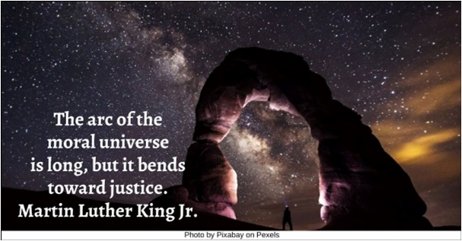

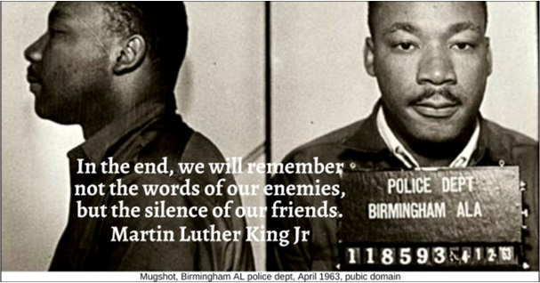

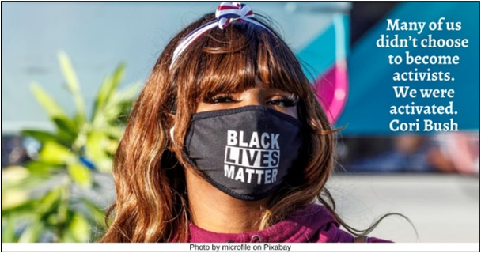

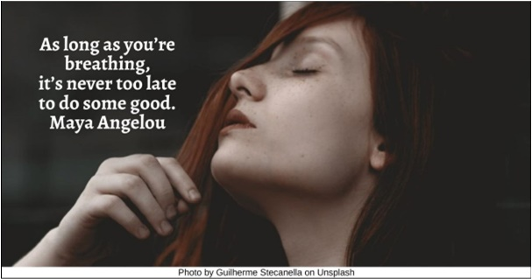

Broken Heart HRJ
Burning Candle HRJ
Candle for Meditation HRJ
Chains HRJ

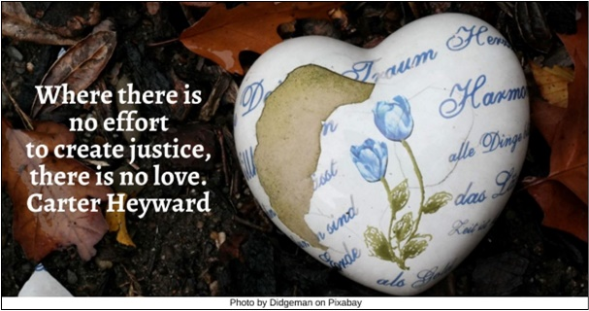

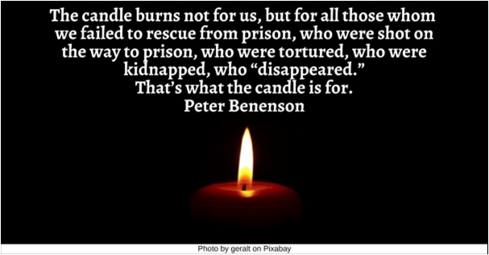

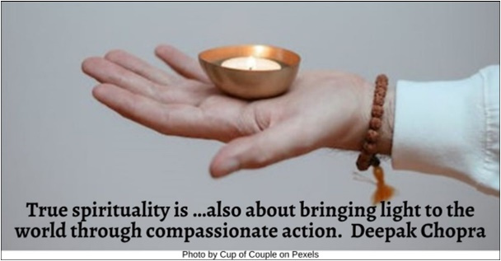

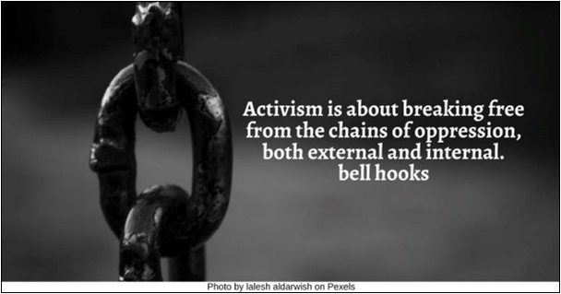

Change HRJ
Child HRJ
Church HRJ
Climate Justice HRJ

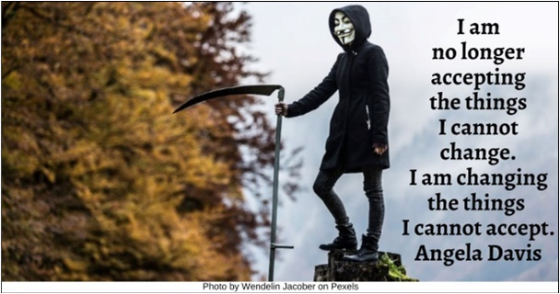

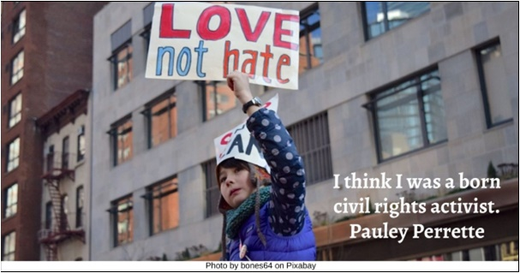

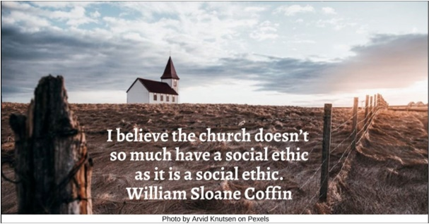

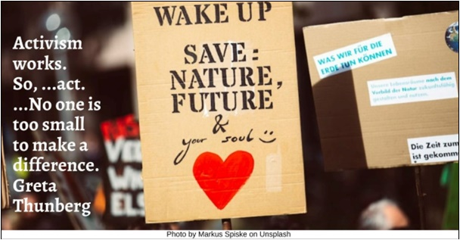

Earth HRJ
Environment HRJ
Future HRJ
Helping Hands HRJ

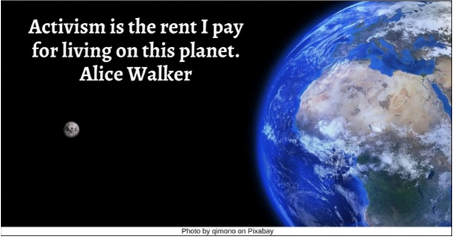

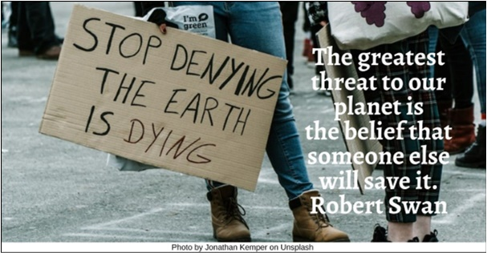

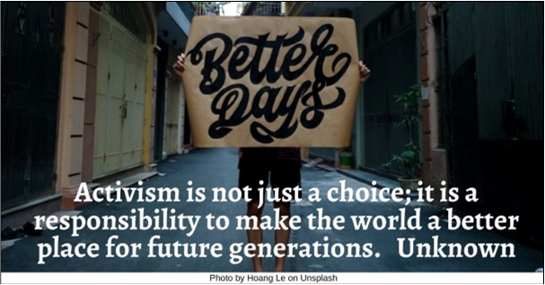

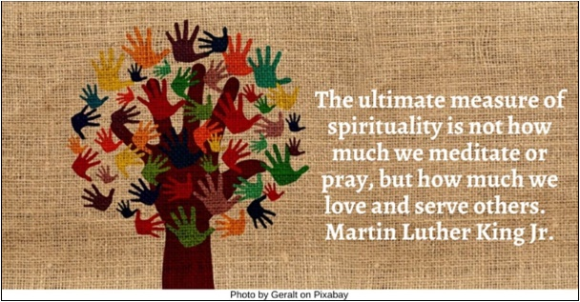

Hope HRJ
Hourglass HRJ
Imagination HRJ
Injustice HRJ

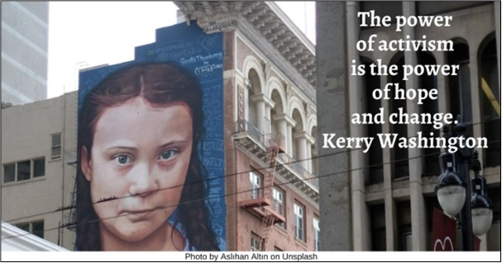

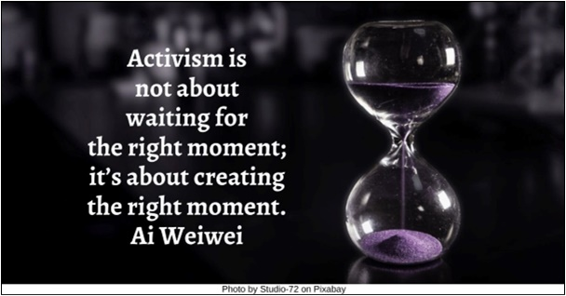

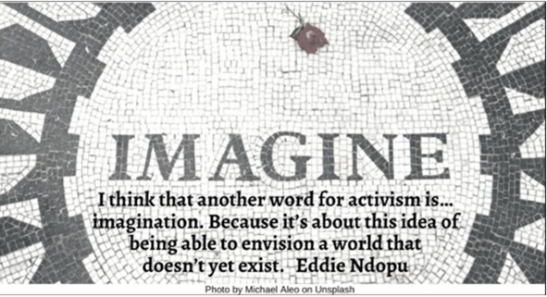

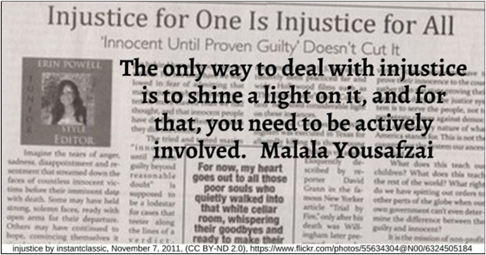

Law HRJ
Make a Difference HRJ
Marathon HRJ
No One Thing HRJ

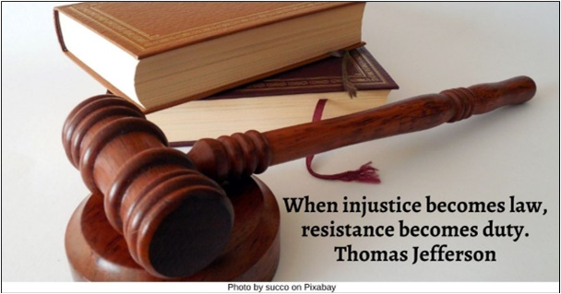

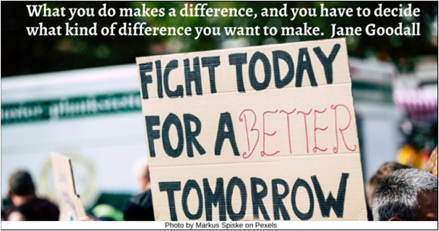

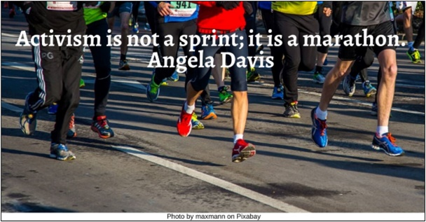

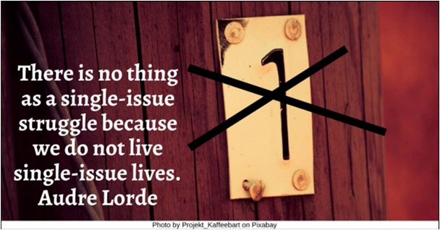

Ordinary People HRJ
Silence HRJ
Small Group HRJ
Spirituality HRJ

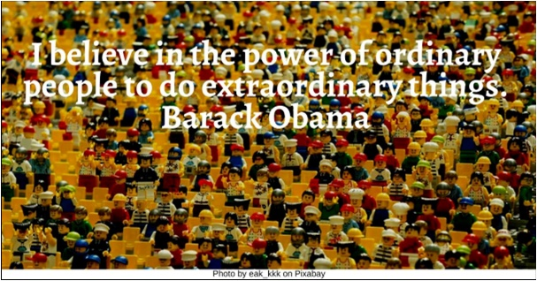

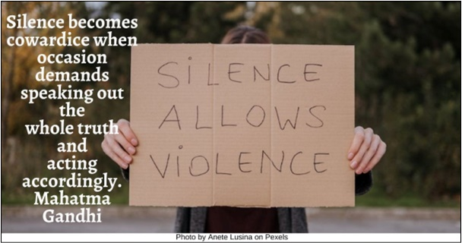

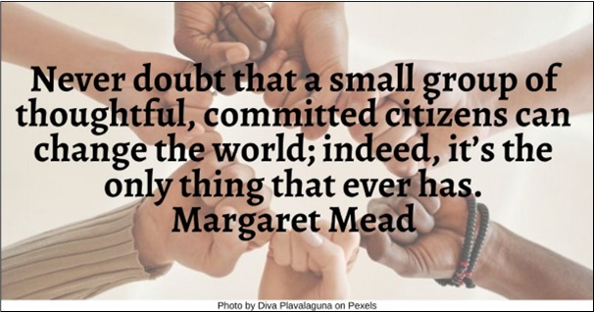

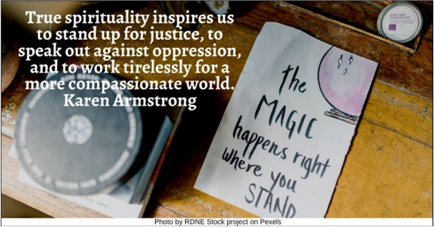

The Ones HRJ
Walking with cane HR
Women’s Protest HRJ

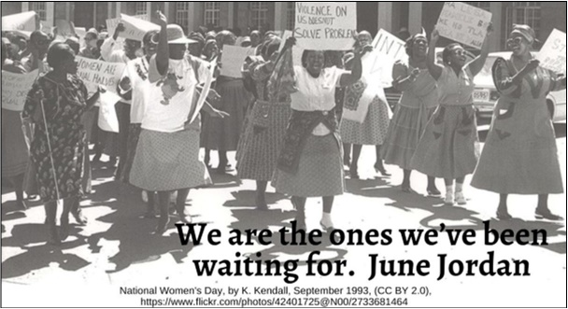

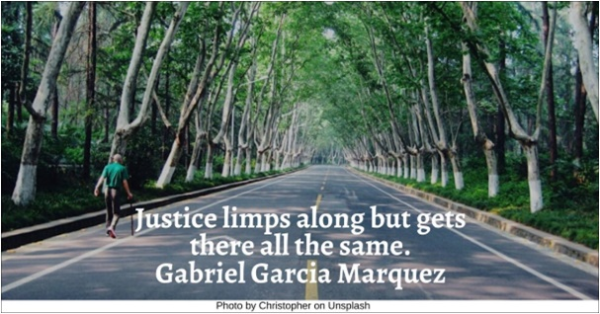

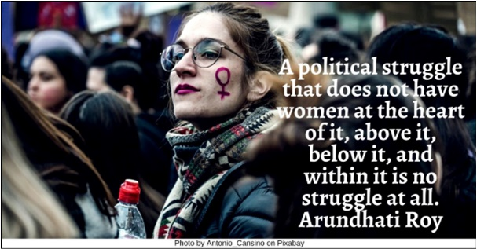

Text of Quotes
Arc HRJ
The arc of the moral universe is long, but it bends toward justice. Martin Luther King Jr.

Birmingham Jail HRJ
In the end, we will remember not the words of our enemies, but the silence of our friends. Martin Luther King Jr.

BLM Protestor HRJ
Many of us didn’t choose to become activists. We were activated. Cori Bush

Breathing HRJ
As long as you’re breathing, it’s never too late to do some good. Maya Angelou

Broken Heart HRJ
Where there is no effort to create justice, there is no love. Carter Heyward

Burning Candle HRJ
The candle burns not for us, but for all those whom we failed to rescue from prison, who were shot on the way to prison, who were tortured, who were kidnapped, who “disappeared.” That’s what the candle is for. Peter Benenson

Candle for Meditation HRJ
True spirituality is …also about bringing light to the world through compassionate action. Deepak Chopra

Chains HRJ
Activism is about breaking free from the chains of oppression, both external and internal. bell hooks

Change HRJ
I am no longer accepting the things I cannot change. I am changing the things I cannot accept. Angela Davis

Child HRJ
I think I was a born civil rights activist. Pauley Perrette

Church HRJ
I believe the church doesn’t so much have a social ethic as it is a social ethic. William Sloane Coffin

Climate Justice HRJ
Activism works. So, …act. …No one is too small to make a difference. Greta Thunberg

Earth HRJ
Activism is the rent I pay for living on this planet. Alice Walker

Environment HRJ
The greatest threat to our planet is the belief that someone else will save it. Robert Swan

Future HRJ
Activism is not just a choice; it is a responsibility to make the world a better place for future generations. Unknown

Helping Hands HRJ
The ultimate measure of spirituality is not how much we meditate or pray, but how much we love and serve others. Martin Luther King Jr.

Hope HRJ
The power of activism is the power of hope and change. Kerry Washington

Hourglass HRJ
Activism is not about waiting for the right moment; it’s about creating the right moment. Ai Weiwei

Imagination HRJ
I think that another word for activism is… imagination. Because it’s about this idea of being able to envision a world that doesn’t yet exist. Eddie Ndopu
Injustice HRJ
The only way to deal with injustice is to shine a light on it, and for that, you need to be actively involved. Malala Yousafzai

Law HRJ
When injustice becomes law, resistance becomes duty. Thomas Jefferson

Make a Difference HRJ
What you do makes a difference, and you have to decide what kind of difference you want to make. Jane Goodall

Marathon HRJ
Activism is not a sprint; it is a marathon. Angela Davis

No One Thing HRJ
There is no thing as a single-issue struggle because we do not live single-issue lives. Audre Lorde

Ordinary People HRJ
I believe in the power of ordinary people to do extraordinary things. Barack Obama

Silence HRJ
Silence becomes cowardice when occasion demands speaking out the whole truth and acting accordingly. Mahatma Gandhi

Small Group HRJ
Never doubt that a small group of thoughtful, committed citizens can change the world; indeed, it’s the only thing that ever has. Margaret Mead

Spirituality HRJ
True spirituality inspires us to stand up for justice, to speak out against oppression, and to work tirelessly for a more compassionate world. Karen Armstrong

The Ones HRJ
We are the ones we’ve been waiting for. June Jordan

Walking with cane HRJ
Justice limps along but gets there all the same. Gabriel Garcia Marquez

Women’s Protest HRJ
A political struggle that does not have women at the heart of it, above it, below it, and within it is no struggle at all. Arundhati Roy

